**What is Database?**

* Database is a well organised or structural collection of the data stored in the computer.
* Database is managed by the system called Database Management system also called **DMBS**.
* There are almost 11 types of databases exists in the computer world but the most common one is the
* **Relational Database.**

**Relational Database**

* In this type of database, the data is stored in the form of the **table** which further consist **rows** and **columns**.
  + **Table**: It is a database object which is organised in the rows and columns format (like a spreadsheet).
  + **Row**: Row is also known as record which consist data in horizontal line.
  + **Column**: Column in a table which store data vertically.
* There are many other formats of storing data in database other than table exist but this one is most common and most easy way to store data in database.

Example: The data which is provided for the assignment of the **SPOTTABL** is also in the form of rows and table.

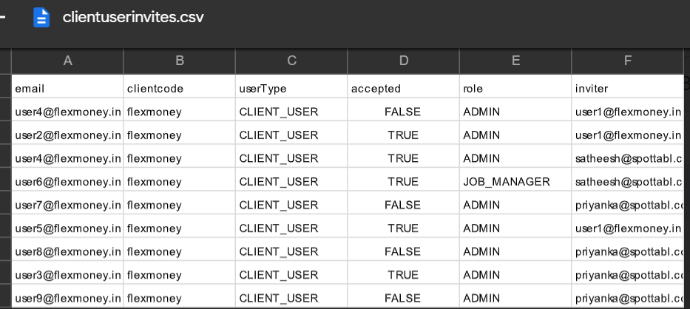

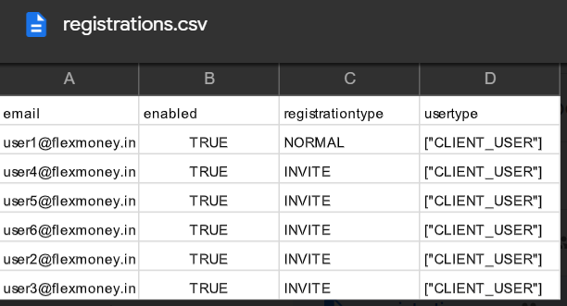

* DBMS use to manage the Relational Database is called **Relational Database Management System** also known as **RDBMS**.
* The RDBMS allows to **CREATE**, **READ**, **UPDATE**, **DELETE** the data from the database (relational database).
* The **SQL** (Structured Query Language) is language which use to write command in **RDBMS** and hence based on the type of query like create, read, update and delete there are different categories of query exist in SQL.
* **Data Definition Language** (DDL): Use to create/define the database.
  + - Example: CREATE DATABASE Spottabl;
* **Data Manipulation Language** (DML): Use to Manipulate/update/fetch the data.
  + - Example: Select * from registrations

UPDATE registration SET enabled = ‘False’ WHERE registrationtype = ’NORMAL’;

* **Data Control Language** (DCL): Use to give privileges to the different users.
  + - Syntax: GRANT privilege_list ON Object_name TO user_name;

**Concept of SQL**

* **Primary key**: A column or a group of columns taking which is unique for all the record in the table.
  + Example: Here email is the primary key of the table registration



* **Foreign key**: Foreign key is a column or a set of columns which use to link the two or more table in a database.
* Generally foreign key is primary key in other table.
  + Example:

PrimaryKey for **registration** table and foreign key for **clientuserinvites** table 



* **Index**:
  + A index is the ordered is reference to the one or many record in the database which can be later use to find/search the data which.
  + Index is generally use to make a good working of the database.
* **Datatype**: SQL data type is an attribute which specify the type of data that can be stored by any object in the table.
  + Example:
    - bigint
    - int
    - smallint
    - tinyint
    - bit
    - char
    - varchar
    - etc.